Valuating Open Source Software Adoption for Public Sector

Androklis Mavridis and Ioannis Stamelos
Department of Informatics, Aristotle University of Thessaloniki
amavridis@csd.auth.gr, stamelos@csd.auth.gr

Introduction
Worldwide, governments start implementing nationwide policies promoting FOSS [1]. The primary motivations for implementing OSS in the government sector ranges from minimizing software acquisition costs to increasing flexibility and avoiding vendor lock-in, while at the same time improving local software development skills [2].
Recently many studies have reported the benefits of using OSS within the public sector [3], and while the benefits and the motivation drivers may vary for governments, there are successful examples that have moved towards OSS [4]. However, there is still lack of awareness and unwillingness towards adoption of open source software by public administrations. The FLOSSPOLS survey partially attributed this reluctance in the existence of insufficient practices in public procurement that lead to non-transparency and prejudice in software procurement, as public administrations may not be aware of the feasibility of open source software adoption in their environments.
In [5] authors recognize that the selection and the eventual adoption of the OSS application should be also based on the offered quality on top of the desired functional requirements that in any case should be met. They also argue that even though numerous available quality models exist providing metrics for assessing the quality of the OSS, their application is perceived by the public sector as a fairly complex task and thus, performed rarely.
While the importance of risk management application in information systems projects implementation has been identified, studies have shown that public sector is characterized by risk averseness [6] [7] [8]. In spite of budgetary constraints and higher demand for accountability and transparency of public investments, authors in [9] argue that public sector shows little interest in financial performance.
This attitude can be justified at large by the fact that public sector organizations do not produce measurable revenues and thus traditional accounting techniques such as Return on Investment (ROI) cannot adequately measure the value of these investments [10]. The selection of a candidate OSS further magnifies the organization’s inability to valuate the expected benefits/profits.
This is due to the abundance of competing OSS applications, to the evolving quality of the OSS application which directly affects its value, and to the lack of pricing models able to translate the impact of the OSS selection into monetary benefits. To cope with the vast availability of possible OSS candidates, numerous software evaluation methods have been proposed measuring various quality aspects.

In this report we present an alternative approach for the evaluation of OSS by Public Sector (PS), focusing on managing and mitigating the risks and on maximizing the value generated from the OSS adoption.
The aim is to assist PS decision stakeholders in risk analysis-management and mitigation procedures by:
- Discovering the risk inherent in the adoption of an OSS application.
- Managing the constant improvements/updates of open source software.
- Assuring that the selected OSS application is the one that better fits to the organization’s IT environment.
- Make the optimum decision regarding when to adopt the right OSS application

Our work builds on three main pillars:
- The volatility of OSS quality,
- The risk attributed to OSS selection,
- The value this selection brings to PS organization.

The purpose of this report is twofold. Firstly, to highlight the concerns and risks faced by public sector organizations in their effort towards transition to Open Source Software and secondly to present how our proposed approach encompasses and manages these risks.
To validate our approach we use as benchmark the “Guide to Open Source Software for Australian Government Agencies”, for the rest of the report shall be referred as (Guide). However, there are various available guides to open source transition produced by several governments, as shown in the recent study performed by the Center for Strategic and International Studies, which can be also used.
In the following section we analytically present our proposed approach while in Appendix section we show through a case study, the overall validity of our method.

1. Risk analysis-management and mitigation
The Guide identifies the following workflow that should be followed upon “In-House sourcing of OSS products”, shown in figure 1 (as extracted from the Guide). We describe how our method tackles each step and achieves the desired risk analysis, management and mitigation milestones set by the Guide. The more simple cases of “External Sourcing” and “Custom Software Development” presented in the Guide can also be dealt following the same steps and reasoning.

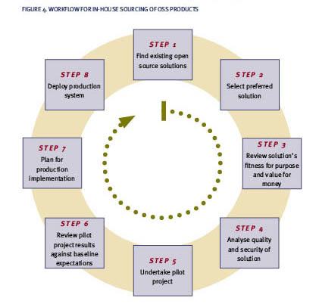
Figure 1 Workflow for In-house sourcing for OSS products

Our method performs three distinct evaluations, for each candidate OSS application. These evaluations are namely Quality, Knowledge and Economic.

  - Quality based OSS evaluation
In this step we assess each candidate OSS application against the same list of quality attributes. Many of the available approaches can be used, as long as they provide adequate metrics and allow weights to be assigned for each metric (or category of metrics) expressing user preferences. The most representative and well known “state of the art” methods are the:
- OSMM (Open Source Maturity Model) [11],
- Open Business Readiness Rating (OpenBRR) [12]
- Open Business Quality Rating (OpenBQR) [13]
- Qualification and Selection of Open Source Software (QSOS) [14]
- The SQO-OSS Quality Model [15]
- QualOSS [16]
The aforementioned methods however, perform a time static quality assessment. They lack mechanisms able to handle the changes in quality dictated by the rapid development, rapid evolution of software, and the frequent releases in OSS realm [17]. Also they cannot tackle the possibility of quality tradeoffs emerging upon OSS integration to an existing IT environment. These tradeoffs provide a clear indication of the negative correlation between the selected attributes. For example, enhancing the level of encryption could have a positive impact on security but possibly negative on performance.

To solve these two fundamental shortcomings we calculate the volatility of the OSS application quality.

Having the quality assessment scores from the application of the state of the art evaluation methods, we perform Monte-Carlo simulation, to discover the volatility. The output of the simulation is the total assessment score obtained, while the input variables are the scores of each attribute assessed. For each attribute a distribution is defined along with the min, max or mean values (i.e uniform, normal, triangular etc). To select the appropriate distribution, an examination of the factors influencing the volatility of the OSS application [18] should be performed.
These are factors, such as degree of community involvement, development forks, reported bugs, document support, number of updates committed to the server etc. An adequate list of these factors can be found in OSMM, OpenBRR, QSOS and SQO-OSS. Alternatively, we can monitor the volatility of the selected applications by monitoring the changes of the quality characteristics through their respective versions, or the changes occurred in similar applications of the same domain. The outcome of the Monte-Carlo simulation is the list of volatilities (expressed in % figures) for the candidate applications.

The benefits from the Quality based evaluation phase are:
- Measurement of the OSS quality volatility over a given period of time.
- Identification of the quality tradeoffs in the specific environment.

Guide steps coverage
Through our quality evaluation phase we cover Step 1, Step 2, and Step 4

  - Knowledge based Evaluation

At this step we calculate the value, in the form of expected revenues, and the costs from the usage of candidate OSS applications. The problem is that Public Sector Organizations, by nature, do not produce measurable revenues. Traditional accounting techniques are of little use. To overcome this constraint we employ the Knowledge Value Added methodology (KVA) [19].
KVA helps translating the knowledge used in the organizations processes, into a form allowing the allocation of revenue in proportion to the value and the costs created by the usage of this knowledge [20]. KVA defines knowledge as the know-how required to produce the organization process outputs. As this knowledge is proportionate to the time it takes to learn it, learning time can be used to measure the amount of knowledge contained in any given process. KVA provides the means to justify investments in IT, when organizations wish to automate their processes [21], [22].

We are interested in the revenue allocated to the amount of knowledge required to complete the organization’s process. To identify this revenue we calculate the learning time estimates, by measuring how long it would take for the organization’s average IT personnel to learn how to manually perform the instructions (the ones to be performed by the candidate applications) and produce the same outputs.

Following the same reasoning the cost to execute the process knowledge is represented by the actual time it takes to execute the process, multiplied times resource costs: labor, machines, etc.

The benefits from the Knowledge based evaluation phase are:
- Calculation of actual profits and costs from the employment of the OSS application in the specific public Sector environment.
- Actual participation of the IT staff.
- Ensuring that the selected application would be operated by the responsible personnel in a time and cost efficient manner.

Guide steps coverage
Through our Knowledge evaluation phase we cover Step 5 and Step 6

  - Economic based Evaluation (Real Options Valuation)

The more the OSS application evolves over time the more its quality and hence its monetary value will change (fluctuate up or down) over time. Thus, the objective of the selection process is to adopt a candidate application at the point when its application’s quality will be at its pick. This decision obviously should be made during a certain time period which is the period until the selection time expires.
To buy, this extra time waiting to see how the applications’ quality will evolve, the team should pay the premium. To clarify the mechanisms, lets consider an application whose value is initially So and an option on the application’s selection whose current value is f. Suppose that the option lasts for time T (time to select). During the life of the option, the application value (due to its quality) can either move up i.e. the project community enhances the quality of the given application, from So to a new level, Su or down, i.e the community stops supporting the application and thus its quality value decreases, to a new level Sd.
The proportional increment in the application’s value when there is an up movement is u-1; the proportional decrement when there is a down movement is 1-d. If the application value moves up to Su, the payoff from the option is assumed to be fu; if the stock price moves down to Sd, the payoff from the option is assumed to be fd. From this point we team can calculate the binomial options value by applying the following expression:
Value = ([p * Option up + (1-p) * Option down] * exp (- r * ∆t)),
r is the risk free rate corresponding to the life of the option,
p is the probability of an up movement factor,

Our Real Options Analysis builds for each candidate application three binomial lattices based on the American call option fashion, which dictates that the option (the selection) can be exercised at any given time until the expiration.
The first lattice calculates the expected revenue fluctuations, the second calculates the premium value that should be paid for this call option, and the third, shows when is profitable to exercise the option. We identify two options for each candidate application following the American options fashion (can be exercised at any given time). These are:
- The ”option to defer” - the team can wait to see if the value attributed to application’s quality has been the one expected, referring to a case where the team stalls the adoption of the selected application foreseeing that waiting for a certain amount of time, changes negative or positive on offered quality will occur.
- The option to abandon - referring to the case where the team abandons the selection process at any given time during the selection period.

As we have more than one candidate applications, this actually implies a portfolio of options. The binomial options valuation approach fits to our selection problem, as at every given moment we can have two options, the option to wait and the option to abandon.

The benefits from the Economic based evaluation phase are:
- Optimum Decision on when to adopt OSS applications.
- Selection of the most cost – benefit OSS solution in the foreseeable time frame.
- Minimization of risks based on Quality and technology uncertainties.

Guide steps coverage
Through our Economic evaluation phase we cover Step 3 and Step 7

Concluding Remarks
Our method assists Public Sector organizations on OSS applications selection by taking into account their specific requirements and constraints. Apart from risk management and profit optimization, we address some fundamental issues, like the lack of accountability and risk averseness.
We proposed a blend of evaluation methodologies and valuation analysis able to give insights to risks anticipated due to future uncertainties on the qualities of OSS applications. By doing so, we provide an alternative view to the selection process in the uncertain Open Source Software realm. By perceiving the OSS adoption as an option risky investment, we are able to discover the anticipated value of OSS employment to specific PS environments and of providing reasoning for selecting the most cost effective OSS option. Our method is applicable to closed software as well with different conditions taken into account.
References

[1] Wong, K., (2004). Free/Open Source Software: Government Policy, Asia-Pacific Development Information Programme e-Primers on Free/Open Source Software, (UNDP-APDIP)
[2] Kovacs, G.L., Drozdik, S., Zuliani, P. Succi, G. (2004). Open source software for the public administration, Proceedings of the 6th international workshop on Computer science and information technologies, Budapest, Hungary.
[3] Waring, T., Maddocks, P. (2005). Open source software implementation in the UK public sector: evidence from the field and implications for the future, International Journal of Information Management 25, 411-428
[4] Richter, D., Zo H., Maruschke M., (2009). A Comparative Analysis of Open Source Software Usage in Germany, Brazil, and India. Fourth International Conference on Computer Sciences and Convergence Information Technology. November 24-26, 2009, Seoul, Korea.
[5] Gosh, R.,A., Glott, R., Schmitz, P., E., Boujraf, A., (2008). OSOR Guidelines, Public procurement and Open Source Software. Public draft version 1.0. Unisys Belgium, UNU-MERIT
[6] Vilvovsky, S., (2008).Differences between Public and Private IT Outsourcing: Common Themes in the Literature The Proceedings of the 9th Annual International Digital Government Research Conference. Montreal, Canada, May 18-21 2008.
[7] Dawes, S. S., Pardo, T. A., Simon, S., Cresswell, A.M., LaVigne, M. F., Andersen, D. F., et al. (2004). Making smart IT choices. Center for Technology in Government publication 2004.
[8] Bannerman L. P., (2008). Risk and risk management in software projects: A reassessment Source.Journal of Systems and Software. Volume 81, Issue 12 (December 2008).
[9] Van Der Wal, Z., Huberts, L., Van Den Heuvel, H., and Kolthoff, E. (2006). Central Values of Government and Business: Differences, Similarities and Conflicts.Public Administration Quarterly, 30(3), 314. 2006.
[10] Mun J., (2006). Modeling Risk. (2nd ed.) New Jersey: Wiley Finance.
[11] Golden, B., (2006).Making Open Source Ready for the Enterprise, The Open Source Maturity Model. Extracted From Succeeding with Open Source, Addison-Wesley Publishing Company, 2005.
[12] Business Readiness Rating. Business readiness rating for open source. http://www.openbrr.org.
[13] D. Taibi, L. Lavazza, S. Morasca, “OpenBQR: a framework for the assessment of OSS”, IFIP International Federation for Information Processing, Volume 234, Open Source Development, Adoption and Innovation, eds. J. Feller, B. Fitzgerald, W. Scacchi, A. Sillitti (Boston:Springer), pp. 173-186.
[14] QSOS. Method for qualification and selection of open source software (qsos) version 1.6. http://www.qsos.org.
[15] Samoladas, I., Gousios, G., Spinellis D., Stamelos, I., (2008). The SQOOSS Quality Model: Measurement Based Open Source Software Evaluation. IFIP 20th World Computer Congress, Working Group 2.3 on Open Source Software, pp. 237-248, Springer.
[16] M. Ciolkowski, M. Soto, “Towards a Comprehensive Approach for Assessing Open Source Projects”, Towards a Comprehensive Approach for Assessing Open Source Projects. In Proceedings of the international Conferences on Software Process and Product Measurement (Munich, Germany, November 18 - 19, 2008).
[17] Feller J., Fitzgerald B. (2000). A Framework analysis of the open source software development paradigm Proceedings of the twenty first international conference on Information systems. ICIS ’00. December 2000, Brisbane, Australia.
[18] Deprez, C.J, Monfils, F.F, Ciolkowski, M., Soto, M. (2007). Defining Software Evolvability from a Free/Open-Source Software Perspective, Third International IEEE Workshop on Software Evolvability, Paris France, Oct. 2007.
[19] Housel, J., T., Kanevsky, V., (2005). Knowledge Value Added (KVA) Methodology, The International Engineering Consortium. Http://www.iec.org. 2005.
[20] Cook, R. G, Housel, T. (2005). Where to Invest in Information Systems: A CRM Case Study, Proceedings of the 38th Hawaii International Conference on System Sciences, January 3-6.
[21] Wu, Y.L, Wu, C.C, Yang, P. C. (2007). The Use of Knowledge Value Added to Weigh the Performance of Information Technology Outsourcing, International Conference on Wireless Communications, Networking and Mobile Computing, 2007. WiCom 2007, Shanghai, 21-25 Sept.
[22] Waymond, R., Housel, T.J. (2009). Measures for organizations engaged in a knowledge economy, Journal of Intellectual Capital, Vol:10, Issue: 3, 2009, pp: 341 - 353.
Appendix

In this section we present the process and the results of the application of our methodology to a case study. A public sector organization decided to make available to citizens a series of public services online, through the employment of semantic web technologies. To implement the demonstration services the organization had to select between WSMX, the reference implementation of the Web Service Modelling Ontology (WSMO) and the OWL-S (Ontology Web Language for Services) tool suites.

Quality Assessment
The organization’s IT department performed a quality based assessment applying the OpenBRR methodology as it had employed it before in a similar assessment context. Apart from functionality, the team selected the Usability, Security, Performance, Quality, Documentation and Community as the most suitable for assessing the two suites. For each of these qualities, OpenBRR provides a set of metrics. Figure 2 and Figure 3 present the tables with the results of the two assessments.
To avoid confusion, the Quality characteristic shown in the assessment tables, do not represent the overall quality of the suites but the Quality category of metrics offered by the OpenBRR framework. As the assessment scores were quite close, we offered assistance and applied the proposed valuation methodology on top of OpenBRR results.

Quality Volatility
The first step was to discover the quality volatility factor expressed as % percentage of the assessment scores fluctuation. To calculate volatility we asked the IT team to assess also the Support, Adoption and Professionalism attributes for the two candidate tool suites. Based on this assessment we asked them to identify which quality attributes and to what degree they could anticipate changes over a one year period.
The time period was set to one year as the organization had by that time, a sixteen months time frame to complete the demonstration services. With the team’s help, we identified the distributions and the range of values to be applied on the selected quality attributes to Monte Carlo simulation.

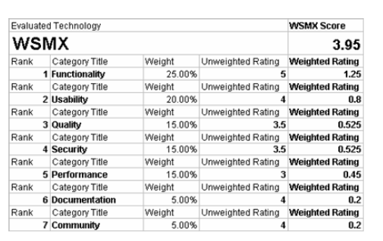
Figure 2 WSMX Quality Assessment

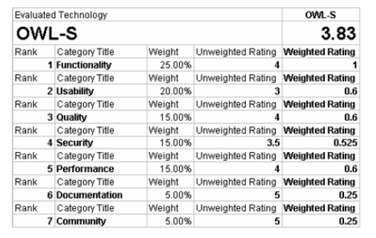
Figure 3 OWL-S Quality Assessment

Performing the simulation for WSMX we found the volatility (standard deviation)
to be 13,09%, meaning that the team anticipates that the overall quality score of 3,95 will fluctuate positively or negatively by 13,09%.
Performing the simulation for OWL-S suite the team found quality volatility to be 18,70% of the total score. The results from the simulation indicate that although OWL-S scored lower in the OpenBRR assessment session, it might eventually overcome WSMX in the given time horizon.

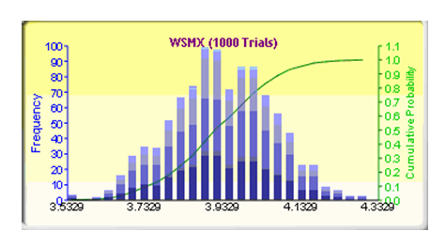
Figure 4 MonteCarlo Simulation for WSMX

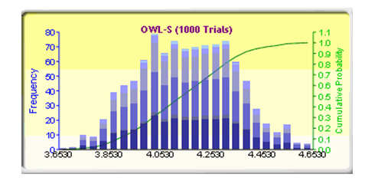
Figure 5 MonteCarlo Simulation for OWL-S

Knowledge based evaluation
Next, we applied the KVA methodology for calculating the value and the costs of our suites for the process Building Semantic Web Services (BSWS). Doing so, we could identify the value and the cost attributed to the suites when employed in fulfilling the process. The BSWS process was decomposed into seven sub-processes:
- Building ontology
- Creation-Discovery
- Grounding
- Mediation
- Orchestration-Choreography
- Storing
- Execution
The amount of knowledge embedded in a process can be represented by the amount of time required by an average person to learn how to perform the process efficiently. To estimate the knowledge value added attributed to the suites in the process, we had first to include the process automation within estimates of sub-process learning times. All logged times were in hours. Then we asked the team to provide the time estimates of how long it would take to the average IT member to learn to produce the instructions performed by the suites manually. The estimates of training times were used for calculating the amount of knowledge contained in the suites for the given sub-processes.
The total cost of manually performing all seven sub-processes constructing a single service, was used as surrogate for the revenue attributed to the suites performing the same task.
The rationale is that the organisation saves money (revenue) for each single service built, when the suites are employed. Thus, the revenue Rs, is the value of the suites (the knowledge value required to learn how to perform the process) Vs, plus the cost of manually executing the process Cm, minus the cost of executing the process through the suites Cs.
Rs = V s + Cm - Cs, where V s = ((LT + OJT) * HPC) is the total training times estimate (learning times LT and on the job training OJT), multiplied with the hourly personnel cost HPC. Cm is the total time to execute the process manually multiplied with the hourly personnel cost, and Cs is the time estimates it takes to execute the sub-processes through the suites, multiplied with the hourly personnel cost. The average hourly labor rate was given of 12,5 Euros (for convenience all prices presented in the following sections are expressed in Euros). Having collected the time estimates the results for the WSMX suite are shown in Table1 and in Table2.
The execution times of sub-processes with and without the suite employment
are shown in table.

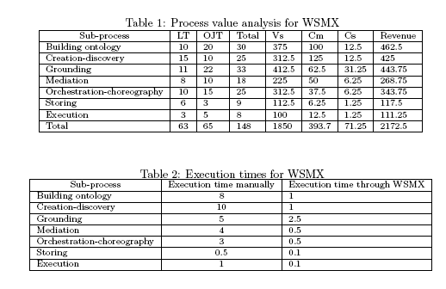
Similarly for the OWL-S the results are shown in Table 3 and Table 4
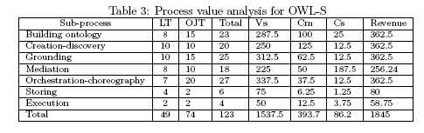
The team mainly attributed the differences in learning and execution times, to existing differences in the mediation, groundings and choreography capabilities of the two suites. The results from the KVA analysis showed that WSMX had higher revenues and lower execution costs per process in contrast to OWL-S.
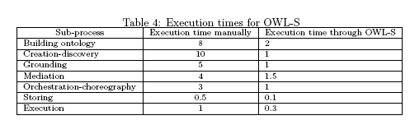

Economic based valuation
Though the results from the previous step were suggesting to select the WSMX suite, we wanted to examine how the quality volatility discovered in
the previous steps, may play a role in the final decision. Firstly, we had to explain to the team the rationale behind options analysis, its applicability to our context and the basic mechanisms of options pricing. After discussions with the team’s manager, we decided to use as exercise price values, in the binomial lattice calculations, the Vs values from the previous step.
The rationale behind this decision was the fact that the team considered the total learning times spent for each suite as investments that had to pay back. In other words if at some future time point the revenues fall behind the investment value then the selection of this suite would be pointless. The manager pointed out the total revenues TR for each candidate should be the revenues R computed per service in the previous step multiplied by the number of team members NoM (the members implementing the services) and multiplied by the number of services NoS to be implemented:
TR = R* NoM * NoS
Following the same rationale the total exercise price TEP is the exercise price per service multiplied by the number of team members TEP = V S * NoM
representing the total accumulated knowledge expressed as the total investment
made by the PS. The three IT department members planned to implement roughly 50 services. Having these constraints, we performed the options calculations. For WSMX we have the following data:
- Number of Members (NoM) = 3
- Number of services (NoS) = 50
- Revenues per service (R) = 2.172,5
- Total Revenues (TR) = 325.875
- Exercise price (Vs) = 1.850
- Total Exercise Price (TEP) = 5.550
- Time to expiration = 1 year
- Risk free rate = 5%
- Volatility = 13,09%
- Binomial steps = 5

Where ”Time to expiration” denotes the time frame the team had to select one of the two suites. We produce three lattices for each suite. The first lattice, namely Underlying Suite Value, shows the way the expected revenues fluctuate based on application’s quality volatility. The upwards fluctuations denote favorable conditions in year’s end, whilst the downwards denote unfavorable conditions respectively.
By conditions we define all the factors that can affect the application’s quality, from community support to bug fixes etc. The second lattice, namely Option Valuation, calculates the premium of the call option. In other words it calculates how much it costs for the team to wait for one year to see if conditions will alter negatively or positively. The third lattice, namely Decision, shows the American call options decision tree. The team can exercise the option at any given time within a year but at the expiration date it is profitable to execute the option (to select the application).
The analysis gives the premium price for the WSMX selection to be 320.595,68. That is the value that the team should ”pay” waiting for one year to see if the WSMX quality has been increased or not. In other words that is the team’s accumulated value not used for the anticipated job.


Figure 6 Binomial Lattices for WSMX

Similarly for OWL-S suite we have the following information:
- Number of Members (NoM) = 3
- Number of services (NoS) = 50
- Revenues per service (R) = 1.845
- Total Revenues (TR) = 276.750
- Exercise price (Vs) = 1.537.5
- Total Exercise Price (TEP) = 4.612
- Time to expiration = 1 year
- Risk free rate = 5%
- Volatility = 18,70%
- Binomial steps = 5

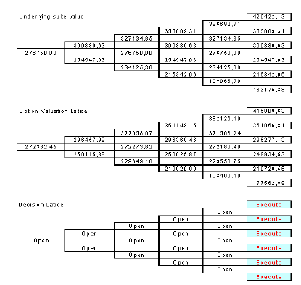
Figure 7 Binomial Lattices for OWL-S

The analysis gives the premium price for the OWL-S suite to be 272.362,45. The difference between the two premiums is 48.233,23. The manager and the team members were quite surprised by the outcome of the analysis. They realized that having this comparison between the premiums, can virtually discover the most cost effective option (candidate suite), in terms of investment planning process.

http://www.finance.gov.au/publications/guide-to-open-source-software/
http://csis.org/files/media/csis/pubs/0807218_government_opensource_policies.pdf

