West Macedonia Region (Greece) – Wiki.ellak.gr and OpenGov platform

Background information

Using poor technology to achieve high impact. This motto has been inspiring the work of GFOSS – Open Software Alliance in Greece, in collaboration with the Institute of Communications and Computer Systems (ICCS) when the organisation has been selected to **support the West Macedonia Region (WMR) in the elaboration of its strategic plan for open e-government (2015-2019)**[1]. This project directly aimed at the implementation of the **Greek eGovernment Action Plan for 2014-2020** approved on December 23, 2014 and following on the transparency of public services initiative, the Clarity programme.

GFOSS – Open Software Alliance is a non-profit organization gathering 30 Universities and Research Centres, using and developing open technologies and standards to **promote openness in public administration, education and business**. The organisation has been playing a key role in the development of open Government initiatives in Greece since its creation in 2008.

Some key activities of GFOSS in Greece include:

* Raising awareness about the benefits of using open source software and provide support to the administration in implementing such solutions;
* Fostering cooperation with the business sector to develop services using public data;
* Ensuring a good dissemination of knowledge generated by universities and research centres and use it to increase the openness of the government or improve the services by businesses.
* Providing pro bono legal advises in relation to open technologies and open government initiatives

The strategic plan has a clear focus on **user empowerment** as defined by the EU eGovernment action plan (2011-2015) and many actions are directly linked to the key recommendations provided at the EU level. The regional strategic plan aims at **improving the public services’ users experience** thanks to the creation of a public services catalogue based on a collaborative wiki and the progressive digitalisation of most-used services. There is a strong willingness to publish information in machine readable format and make sure that non-personal public data are easily accessible on the region’s website. The second key actions as part of the strategic plan consists in the **improvement of citizens and businesses’ participation to policy-making processes** with the elaboration of an online participative platform. The plan notably includes the development of an eDeliberation systems to include interested citizens in the elaboration of their regional budget.

The underlying idea of the strategic plan is not only aimed at creating a sustainable and open infrastructure to empower the citizens of the region, but also activate the triple helix ecosystem (cooperation between the government, industry and universities) for the better good of the local communities.

Overall, the West Macedonia Region strategic plan aims at **building a strong basis for the development of future eGovernment solutions and** **supporting efficiency and effectiveness of governments and administration** by making existing information systems of the region interoperable, streamlining processes and recording data in a machine readable format.

More specifically, the project of **collaborative wikification of public services** (<https://wiki.ellak.gr>) consists in the documentation and maintenance of an updated list of government processes and administrative procedures on a wiki platform. The advantage of using open and standardised web application such as MediaWiki, is that it is a free, easy to use and with low maintenance costs solution.

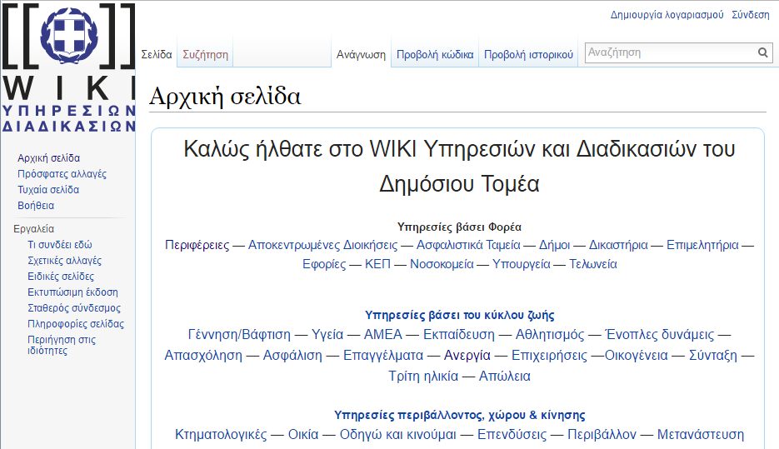

*Figure 1: Screenshot of the Wiki home page* [*https://wiki.ellak.gr*](https://wiki.ellak.gr)

The website is structured around services based on the life cycle of the administrative procedure (e.g. which actions to take following a birth), on specific activities (e.g. get a license to sell on open market) and also across diverse institutions and agencies (e.g. regions, municipalities, hospitals). Public bodies are in charge to record their services in a structured way, including a description of the procedure, a step by step overview, the required documents (with attached forms and/or linked towards electronic procedure) and the legislations on which it relies. All entries in the wiki are cross-linked to allow a smooth navigation between the different topics and avoid any data duplication. The collaborative nature of this system **allows for a constantly enriched content** with new services and procedures updated on a regular basis. So far, about 700 services from the region have been logged on the platform.

As part of the project, GFOSS and ICCS are in charge of the maintenance of the platform and organise a series of training workshops for public administration officials in order to learn to use wiki.ellak.gr but also to implement a solution of the Core Public Service Vocabulary[2] in Greek in order to translate the Greek Public Services Catalogue into a machine readable format. Whenever possible, members of the academic community are integrated to the learning curricula to disseminate the latest knowledge available in the field of Information and Technologies and its application for open government.

GFOSS also supports the region in the **development of more open and collaborative online platform for decision-making**[3], including all open government and eGovernment actions implemented by the Region for the period from 2015 to 2019. The website provides citizens with a simple and user-friendly interface, the possibility to participate to consultation about the strategic plans of the region and to contribute to the improvement of public services through an online idea-box. Citizens can also find a list of all data-set and documents made available by the Region to the public (e.g. financial reports of the region, statistics on health services provided, among others). The all process is eased by the fact that the participation to the online debates does not require any registration.

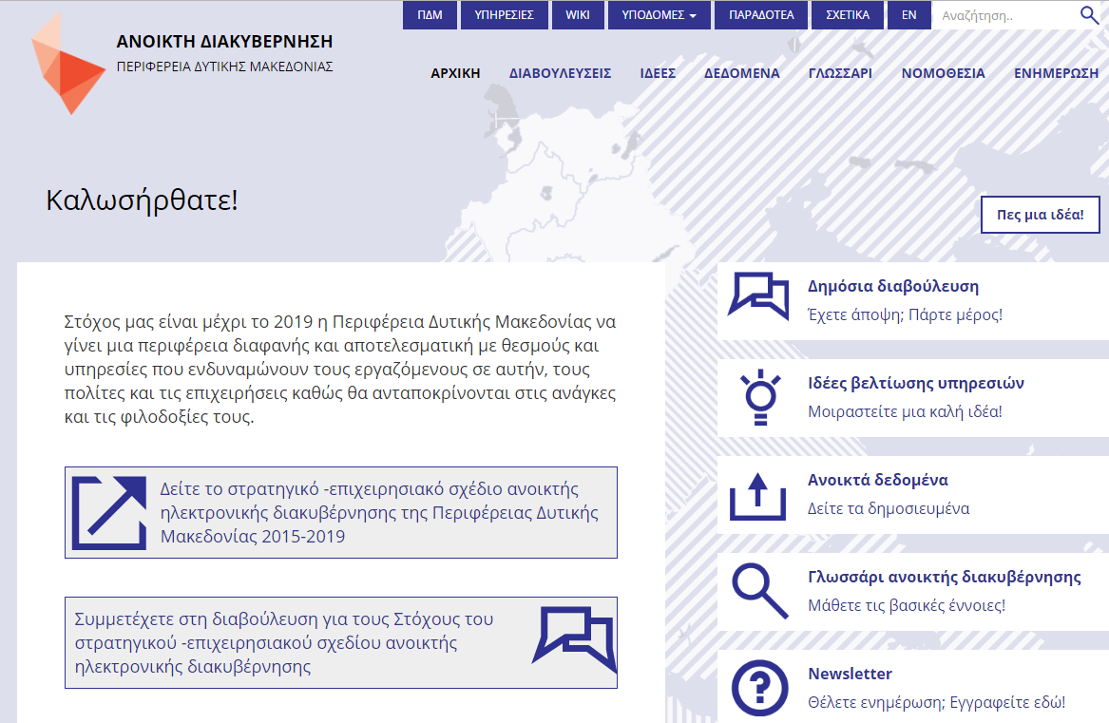

Figure 2: *Screenshot of the Open Governance home page* <http://opengov.pdm.gov.gr/>

Organisational impact

When the government of West Macedonia Region was elected in 2014, they contacted GFOSS – Open Software alliance to assist them in the implementation of the Greek eGovernment Action Plan for 2014-2020. GFOSS agreed on a memorandum of understanding with the region and to collaborate with private companies to which the region outsourced some activities.

The region adopted a strategic plan for open e-government (2015-2019) with 9 key objectives to become an open and efficient region providing services empowering its workers, citizens and businesses by 2019:

1. Engage citizens and community through open e-deliberation
2. Promote the electronic exchange of documents and reduce printed documents
3. Deliver increasing number of electronic services
4. Make the region’s internal organisation accessible and accountable to citizen and businessman
5. Stimulate social innovation
6. Ensure an open participatory budgeting
7. Set-up an online platform to support the work of the ombudsman in addressing complaints
8. Develop smart infrastructures to acquire know-how about private cloud technologies

More particularly, the creation of an **online catalogue of public services** delivered by the region intends to:

* Providing a structured list of services delivered by public bodies and improve the availability of e-services (using electronic or semi-manual solutions);
* Standardising the name and procedure for the similar services provided by different entities;
* Serve as a major step for the simplification of public services procedure (notably by using Core Public Service Vocabulary).

The goal of the region is to progressively ease the administrative procedures with a concrete positive impact for users and transform the public bodies into open and effective organizations.

In parallel, the **online open governance platform** aims at:

* Improving the transparency of the region’s decisions and share non-personal public data;
* Increase citizen participation to decision making.

The key challenge by the region is to establish a long term collaborative relationship with citizens and the civil society by providing channel of participation to the decision making. It is crucial for the region to increase its accountability in order to restore the trust relationship between the administration and the citizens.

***Identification and quantification of Inputs***

The underlying principles of the cooperation between GFOSS and the region were to ensure an optimal use of existing information systems and regional human resources; and secondly, to obtain rapid results within the first year coupled with a responsive development of systems and solutions. The financial resources of the region to conduct this project were limited. The key strategy of the region was therefore to seek for efficiencies between existing systems, create two dedicated web-based platform (the wiki and the participatory platform) with low maintenance costs and train employees to use them.

In terms of work organisation, the implementation of the strategic plan introduced a **more collaborative approach** regarding the delivery of public services and the different services of the region. Not only each department is responsible for the registration of its services in the common wiki, but they also have to link their processes to the related processes or documents issued by other services. The success of the wiki also therefore relies on the active support of executives from the different public bodies and the participation of the employees.

To this end, GFOSS – Open Software alliance has been organising workshops with 104 public servants to raise awareness about the advantage of the collaborative tool and provide training for the use of the platforms as well as the importance to use Core Public Service Vocabulary when recording services and procedures. A guiding principle of the wiki development is indeed to work on the simplification of the processes and the standardisation of the names between the different departments for the delivery of similar services. Up to date, four trainings have been organized, each one focusing on another aspect: 1) General principles about open government and how to manage open data; 2) a non-technical training about open source solutions; 3) introduction to virtual machines and cloud computing; 4) workshop on back-end applications, the systems supporting the two platforms, notably the database of the wiki users.

The creation of a participatory platform allows for a **more open decision-making and direct contributions**, disrupting the traditional and representation-based decision process of the region. Considering the low participation at the moment, no further capacities has been needed to manage the debates and take into account citizens’ point of view into the documents opened for consultation.

In parallel, the region is working to the interlinkage of its different IT systems in order to make them more interoperable and seek efficiencies.

***Identification and quantification of Outputs***

Although the organisation’s structure has not been significantly changed, the introduction of a more collaborative approach, notably linked to the development of the public services catalogue, **increased the cooperation between the different departments of the region**. The management level are working together to simplify processes in a consistent way across the different services.

At the moment, it is **difficult to measure concrete output on the region’s organisation linked to the direct citizens’ participation to the decision making**. On the two strategic plans submitted to public scrutiny (i.e. The Strategic Plan for eGovernment; and the Regional Operational Programme of Western Macedonia 2015-2019), only 2 and 4 comments were respectively received, despite different possibilities offered for commenting (e.g. the online platform, e-mail, by printed forms). No further contribution has been registered in the idea box neither. As a consequence, the strategic decisions by the region have not been strongly impacted.

With regard to the organisational culture, the stakeholders interviewed reported a **genuine buy-in of the region’s civil servants toward open government and related solutions**. The gradual deployment of collaborative solution in the structure impacted the way employees approach problems resolution: they are more incline to look for open-source software/apps and think first about internally designed solutions, rather than to seek a licensed services provided by external contractors as before.

However, the impacts of the project on the middle management is still limited. The lack of leadership in leading eGovernment reforms is currently leading to inconsistent applications.

***Results***

Within the first implementation year of the project, important progress were made:

* The region successfully developed and adopted a strategic plan for open e-government (2015-2019) with 9 key objectives;
* All IT infrastructures and communication tools from the Region were identified and mapped;
* The catalogue of public services based on a wiki and available to the public has been created;
* The online platform for open government platform has been created, offering consultation services, an idea box, and the list of data published by the region;
* The development of an interoperability platform allows for a better communication between the information systems of the different services of the Region.
* Three applications have been designed: 1) to consult the statistic of the regional elections; 2) for the registration and management of licenses to conduct retailing activities; 3) an electronic system for the activation of the region’s employees’ leave (e.g. maternity leave).

There is no doubt that the cataloguing of the services, their standardisation is building a strong basis for the future development of e-services and improve the efficiencies between the different services of the region. There was a huge gap in Greece in the availability of public information regarding open data, best practices, education and training in this sector. This project contributed to the creation of sounds basis for the development of future eGovernment solutions in the region.

However, it remains difficult to overcome the low interest for openness of citizens and foster their participation to the Region decision-making. This low participation can be explained by the lack of information from the public of the possibility to contribute despite promotion tools, the lack of participation culture to public decision-making, distrust in the likelihood of comments to have an impact on the final text, the limited timeframe for participation (less than 1 month), and the difficulties faced by an average citizen in understanding the public documents released for consultation. However, the few comments received were of high quality, clearly written and containing concrete proposals. There is a complete absence of abusive comments.

Financial impact

***Objectives***

The development of open-source solutions and eDeliberation for the West Macedonia Region were not defined in terms of costs savings for the organisation. The main objective of the project was to make the region more transparent and effective by 2019, in line with the Greek eGovernment Action Plan for 2014-2020. No further resources have been assigned to this project on top of the cooperation framework signed between GFOSS and the West Macedonia Region for the years 2015-2016 for an overall budget of XXXX.

***Inputs***

It is clear that the use of open-source software constitutes a lower financial burden compared to software licensing solutions.

The use of MediaWiki, the solution adopted by the region for the public services catalogues, is a free software with low maintenance cost. The tool remains fairly easy to use requesting only a minimum training of the region’s employees to effectively handle it.

***Outputs***

In terms of indirect costs and cost saving, the wikification of the public services and the streamlining of associated processes offer self-serve capabilities to citizens. The availability of the information online and the provision of e-services can reduce demand on staff, which in turn can be considered as an indirect cost saving. The quick development of the project contributes also to the cost efficiency of the solution.

The resources made available thanks to the streamlining of the information and digitalisation of services can be used to meet the additional requests expected from increased citizens’ participation via the online open government platform, even though contributions are at the moment limited.

***Results***

The region aims to implement the national eGovernment action plan as soon as possible with the least impact in term of organisational and human resources impact. An evident constraint was the lack of budget and the necessity to achieve this key objective while reusing existing information systems and human resources. No official financial nor cost savings targets have been established for this project. It is therefore difficult to assess any financial impact linked to its implementation and potentially compared the costs in the event the Region would have subcontracted the described actions to a commercial company instead of using open-source software and the help of a non-profit organisation to implement them. Unfortunately, there is no intention to better evaluate the potential cost savings linked to the digitalisation of the services and to the increase efficiency sought between the different departments of the Region.

Considerations on efficiency and effectiveness

The strategic plan of the West Macedonia Region is in line with the vision of the EU Governance Action plan 2011-2015: to develop innovative ways of delivering services to citizens by unleashing efficiencies while at the same time limiting costs.

In terms of efficiency, the wiki of public services procedures has been created to facilitate the access of information of citizens and their comprehension of the procedures. Empowerment of citizens to independently undertake most of the steps needed in a procedure limits not only the administrative burden for the user but also the workload of front-desk agents which is a major source of efficiency and contribute to increase satisfaction of users. The open collaborative space also ensures the possibility for the users to contribute with their ideas to the improvement of the services delivered by the region to better fit their needs.

Considering its constrained resources, the Region had no alternative than to build on its pre-existing information systems and using its current human capital resources to start its transformation toward a more open and efficient government. The decision to call upon the support of a non-profit organisation and the use of open-source software as well as the reuse of existing tools was cost-effective. The region was able to implement several projects during the first year of its action plan, building strong basis for the deployment of future solutions to the citizens.

Conclusions

The West Macedonia Region, in partnership with GFOSS – Open Software Alliance, has made important progress in the limited timeframe of one year to bring to life   the project of becoming a more open, transparent and effective region. This strategic plan is clearly in line with the key actions recommended by the national and EU levels for eGovernment.

The Region has successfully established a collaborative catalogue of its public services, providing streamlined information to the users. This achievements pays the way for the development of further services, notably the digitalization of the most used services of the Region. Public servants have embraced the collaborative nature of the wiki tool and have integrated the benefits of using open-source software in terms of cost effectiveness and flexibility.

With regard to the participatory platform for open governance, the contributions of citizens are still too limited at the moment to identify concrete impact. However the quality of the few comments received were of very good quality which leaves good hope for further take-up.

There is key lessons to take from the implementing team of the project:

1. Political support from the highest political leaders of the Region is a *condicio sine qua non* for the success of the project. However, it is not sufficient;
2. Engagement and support from the middle level management is critical too in order to sustain the impact of the reform on the long term.
3. Finally, the training of a hundred civil servants played a crucial role for the take-up of the reform and the integration of the new tool into the day-to-day work of the administration. Awareness about the benefits of open government are sustained over time by the organization of additional trainings and innovative events such as Hackathon.

Building on the encouraging development during the first year implementation, GFOSS is now seeking to review this cooperation. To this end, the organisation suggested to conduct additional activities for 2016-2017 among others:

* Digitalisation of the most frequently used services provided by the Region;
* Simplification of the most frequently used procedures;
* The introduction of electronic exchange of documents between the regional services;
* The introduction of a eDeliberation tool to allow citizens’ participation to the elaboration of the budget priorities;
* The systematic publication of open and available data sets;

The West Macedonia Region has achieved important milestones supporting its vision to become a more open and efficient region by 2019. The singularity of the project relies in the innovative approach to reform existing information systems, offer new services to citizens and increase participatory possibilities while keeping the costs low thanks to the use of open-source software and solution and counting on the input from current human capital of the region.

1. <http://opengov.pdm.gov.gr/about/>
2. <https://joinup.ec.europa.eu/asset/cpsv-ap/description>
3. <http://opengov.pdm.gov.gr/>