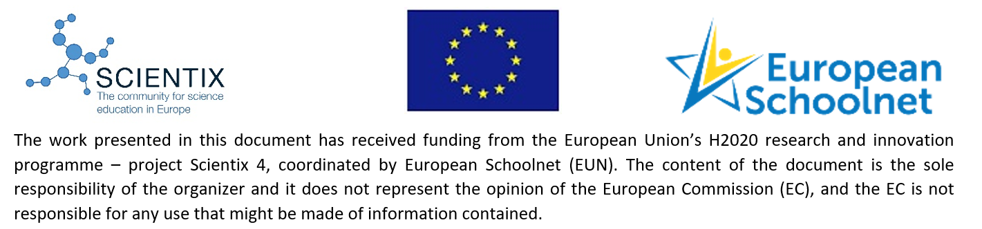
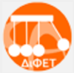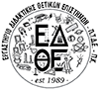
Certificate of Attendance
This certification is awarded to
Sitsanlis Ilias
In recognition of his/her participation as Educator in the Scientix STE(A)M Partnership
“Interplanetary travel: Earth to Mars” and the successful completion of the MOOC
“Earth2Mars” of 10 hours of work from July 2022 – August 2022

The president of GFOSS

John Stamelos

